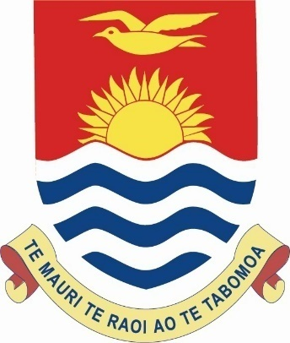

Concluding Remarks
by
Honourable Tangariki Reete
Minister for Women, Youth and Social Affairs of Kiribati
UNIVERSAL PERIODIC REVIEW
HUMAN RIGHTS COUNCIL

United Nations
Geneva
19 January 2015

Mr. President,
Your Excellencies
Members of the Troika
Members of the Working Group for the UPR,
And Distinguished Delegates

I would like to take this opportunity to thank members of the Troika, as well as the member states present for their invaluable contributions to this interactive dialogue. We have listened and taken careful note of all these interventions. Kiribati will take into consideration these comments and recommendations as we move forward to further strengthen our human rights related institutional and legal framework.
Mr. President, as already highlighted, my country is committed to working towards ensuring human rights for all our people is a reality, which is why we are committed to continue our efforts in maximizing these achievements in order for our people to enjoy a better quality of life.

In doing so we acknowledge that there are many challenges and I thank the support of the International Community as well as our key development and regional partners with whom we have enjoyed constructive cooperation in working towards this goal as well as in our preparations for presenting these national developments at this UPR session. We look forward to continuing this partnership.
I wish to reiterate that some of these challenges though are beyond our control, the greatest challenge being that from the adverse effects of the changes to our climate system on the rights of our people to survive. I wish to again highlight that for us, this UPR process will mean nothing if climate change is not addressed as an urgent and major challenge for human rights for all.
Once again Mr. President on behalf of my delegation I extend our sincere gratitude and appreciation for this opportunity to share our story. In closing, let me also share with you all our traditional blessings of Te Mauri, Te Raoi ao Te Tabomoa, meaning Health, Peace and Prosperity.

Thank you.

